- Term II  21st September 2021 | Talent Event Parents/Guardians Newsletter
  We are glad that you have been supportive to nurture our children on both curriculum and co-curriculum activities thus, enhancing the learning process of the entire students in the school. | I take this opportunity to welcome all our pre-school parents to our school for this term's talents will be held on 17th October 2021 in our school compound. Our children are preparing effectively to develop key skills in their relevant art activities that will account for their performance and competitiveness during the upcoming event. We are glad that you have been supportive to nurture our children on both curriculum and co-curriculum activities thus, enhancing the learning process of the entire students in the school. Therefore, it is critical to ensure that each and every one of you are present during the event to allow sufficient opportunity for both staff members and parents to witness the progress of our students as well as take charge in helping them improve in both academics and co-curriculum activities.  Parents as stakeholders of talent development  As you are aware talents development is one of the key obligations of the modern learning process it is critical for every one of us to direct our attention to our children talents development processes and through imposing the talents show fair in our school is one of the major steps that we have made towards the talent development goal. Moreover, it is important for you as parents to take part in enhancing your children’s talents development process through resilient participation in the various vital activities that would improve our student's talents. Further, it is crucial to realize that each student is gifted in a unique way and requires your vigilant observation and guidance to improve their talents across their diverse fields. Therefore, I would call for your tireless support towards our children's talent growth while at home through availing them with the necessary resources that would contribute to the exclusive development of their talents. Similarly, since academics go hand in hand with co-curriculum activities it is important that you supervise your children to go through assigned homework to foster smooth progress of the students in the curriculum sector as well. Currently, the school is in need of more co-curriculum activities facilities and it would be critical for you to attend the function and embrace the obligatory duty of providing the necessary financial support that would find the acquisition of the needed facilities.  City, ST ZIP Code
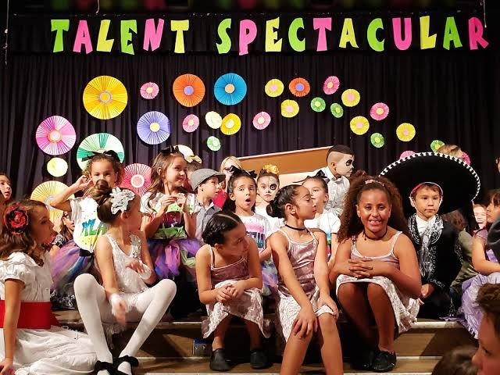  Moreover, co-curriculum activities are essential not only for our kids future but also for the healthy development of the students; thus, as parents, you are required to address this unique need by exposing your children to the available talent development resources such as games kits and art necessities to foster effective development of our children. | Students development resources  I would like to bring to your attention the necessity for students' development resources that would foster better development for our young children and call for your resilient commitment to make use of the available resources in our modern society. Firstly, schools provide a basic framework for students teaching and learning thus, it is important for every parent to provide extra learning materials for the students. Moreover, co-curriculum activities are essential not only for our kids future but also for the healthy development of the students; thus, as parents, you are required to address this unique need by exposing your children to the available talent development resources such as games kits and art necessities to foster effective development of our children. Similarly, more diverse options ought to be ventured to enhance the efficient achievement of flexible talents skills development. Similarly, we ought to consider availing our children a more conducive environment through nurturing their psychological wellness through availing them sufficient time for the growth of better social traits as well as the realization of their unique characteristics as human beings. Additionally, cultivating proper peer social relationship between students would call for similar understanding and relationships and understanding among you parents.  Community resources for students development resources  Finally, it would be vital to inform you on the available resources that can enhance our children's development in both academics and co-curriculum activities in our community; thus enabling you to acquire relevant services suitable for the proper growth and development of our children. Currently, there is a resourceful public library in our city where you can expose your children to access relevant learning materials. Moreover, there are many book stores across the city where you can purchase not only school-recommended learning materials but also co-curriculum guide books for your kids. Similarly, hiring private tutors to assist your children while at home is another resource you can take advantage of.  Lakeview street | City, ST ZIP  Philadelphia,  Pennsylvania, US.  Telephone | Email
Starlit group of schools  Lakeview street  Philadelphia,  Pennsylvania, US. | Pre-school parents/guardians  Philadelphia,  Pennsylvania, US.

